Lizzie Poyant

Intro to Bioinformatics

11/26/18

Lynx rufus distribution

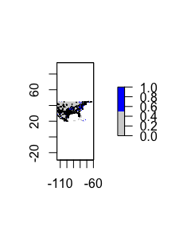

Figure 1: The figure above shows the current distribution of bobcats throughout the US. There is a larger distribution near Texas and near the Northeast region.

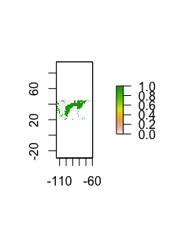

Figure 2: This figure shows the future (70 years) distribution of bobcats in the US.

The species distribution models above show the regions in which the species Lynx *rufus* are commonly found in the Southeastern and Northeastern regions of the United States. Lynx *rufus* is the latin species name for the animal known as the bobcat. This mammal is found in a variety of different areas around the US as it can live in different environments such as the semidesert, the forest, and swampland. This could explain why the Lynx *rufus* can be found in the current distribution (Figure 1) in areas such as northern Texas and the Northeast. This information may not be exact, but it is based off of the Akaike Information Criterion or AIC which estimates the quality of the statistical model used. The models use the lowest AIC generated to find the model with the best fit. The blue region on Figure 1 shows the overall distribution region while the individual black points indicate locations where Lynx *rufus* has been sited and recorded on Gbif through sites like iNaturalist. The Worldclim data is overall pretty accurate in showing the correct distribution areas for the bobcat but there are still many areas such as the upper Floridian region that have sighting but are not included in the general distribution areas. The future distribution model (Figure 2) shows a similar pattern as the distribution of the Lynx *rufus* in Figure 1. There is a slight difference in Figure 2 as the distribution is more widespread in the Northern regions of the United States near places such as Ohio. There is also slightly larger distribution through the Northeast region. This future distribution is not shocking as the bobcats will stay in their desired habitats. My question would be does this model account for things such as climate change as these factors would destroy many of the habitats available to the bobcat.